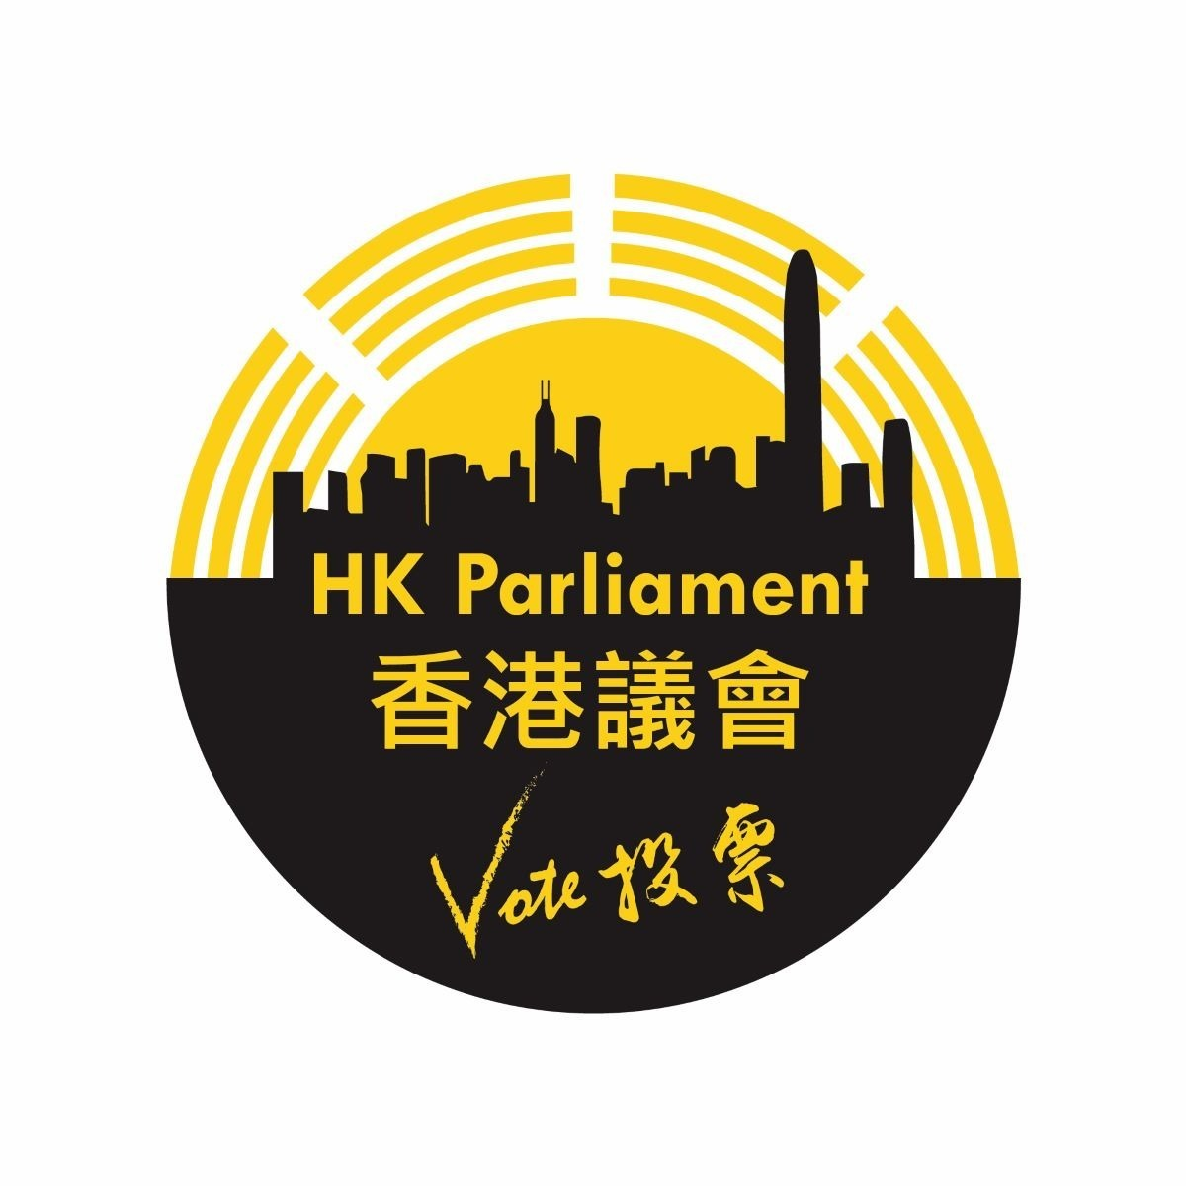
Hong Kong Parliamentary Election Regulations Draft
Scan this code and give comments
Consultation Document 2.0

If you have any questions or comments, please email to support@hkparliament.com or visit https://hkparliament.org/forum-root/participate/public-forum/topic/選舉法草稿集中討論-discussion-on-election-regulations/

Content Page

Preamble ---------------------------------------------------------------------------------- | P.3
Regulations ------------------------------------------------------------------------------  - Electorate Eligibility  - Age Criteria  - Hong Kong Citizenship Stipulation  - Identity Documentation  - Identity Authentication  - Safeguarding Electoral Rights  - Duplication of Votes  - Candidate Eligibility  - Age Criteria  - Residency Requirement  - Identity Documentation  - Candidate Enrollment  - Seat Allocation  - Term of Office  - Form of Election  - The Election Procedure  - Election Fund Regulation  - Oversight of Hong Kong Parliamentary Elections  - Deterrence of Election Malfeasance  - Adjudication of Election Controversies  - Election Revision  - By-elections | P.5
Appendix 1 HK Parliament Mobile Voting Flow Chart -------------------------- | P.9
If you have any questions or comments, please email to
support@hkparliament.com or
visit hkparliament.org

The Hong Kong Parliamentary Election Regulations (Draft for comments)
Announcement date: 1 July 2023
Preamble

The Hong Kong Parliament adopts the principle of electing representatives through a universal suffrage model, each individual being born equal, endowed with inherent human rights, and entitled to one vote. This ensures the vesting of sovereignty directly within the populace, facilitating self-determination, and embodying universal values. The Parliament remains steadfast in its opposition to autocratic rule, striving relentlessly for the continued pursuit of autonomous governance and the preservation of Hong Kong's freedom.

Under Article 25 of the "International Covenant on Civil and Political Rights," all citizens, regardless of gender, race, language, religion, political or other views, nationality, social background, financial status, birth, or other status, enjoy the right to participate in public affairs, vote, and be elected, with the aim of safeguarding universal and equal suffrage. The election must ensure freedom and fairness, and voters must be able to freely exercise their voting rights based on their own beliefs. The election process shall be truly fair and transparent which is supervised by international observers.

The Regulations are to:
- set an electoral threshold, whereby a candidate must obtain at least three percent of the total valid votes per seat to secure a seat in the Parliament. The voting age is set to ensure that voters have sufficient political awareness and mature judgment. Generally, the voting age in various countries is set at 18 years old. However, this age limit is not without controversy, with some advocating for lowering the voting age to 16 years old in order to expand the participation of young people in politics which is significant to their future. This regulation sets the voting age at 16 years old.

- uphold the fairness of the election process, the Hong Kong Parliament Organizing Committee shall establish an independent, neutral, and knowledgeable Hong Kong Parliament Election Commission (“the Election Commission”), to conduct and supervise the election. This measure is expected to enhance voters' trust in the election process.

- ensure that eligible voters fully understand the electoral system and the election process through channels such as education, promotion, and media reporting, and respect the right of voters to be informed.

- safeguard a fair, transparent, and effective electoral dispute resolution mechanism. This mechanism will handle unfair practices during the election and disputes over election results.
- secure the protection of freedom of speech during the election period. All candidates will be able to express their positions and policies equally to the public, including the right to equal access to and use of media resources.

- empower voters to exercise their voting rights in an environment free from interference. The right to vote is not threatened or intimidated, and privacy is protected during the election process.

- maintain the integrity of election results to reflect the effectiveness and fairness of the election. The counting and reporting of votes shall be transparent and tamper-proof.

Regulations

The Hong Kong Parliamentary Election Regulations are established in accordance with the English common law system, and they include:

- Electorate Eligibility: The Hong Kong Parliamentary Election Regulations define the criteria for voter eligibility, such as attaining a minimum age of 16 as of election day and is a Hong Kong permanent resident. Specifically:
  - Age Criteria: Voters must have reached the age of sixteen as of Election Day.
  - Hong Kong Citizenship Stipulation (one of the following conditions must be satisfied):
    - Birth within the territory of Hong Kong;
    - Individuals who have maintained ordinarily residents in Hong Kong for a period of or over seven years;
    - Offspring(s) of 1.2.1 &1.2.2 who constitute the first generation born outside Hong Kong;
  - Identity Documentation: Presentment of a Hong Kong Permanent Resident Identity Card or a valid passport issued either in Hong Kong or a foreign jurisdiction as proof of Hong Kong permanent resident status is mandatory.
  - Identity Authentication: An authorized procedure for identity verification shall be conducted to establish legitimate voter status.
  - Safeguarding Electoral Rights: Throughout the electoral process, protection from any form of coercion, intimidation, or interference including attempts to dissuade or prevent an individual from exercising their voting rights shall be strictly enforced.
  - Duplication of Votes: Qualified electors are only permitted to vote once and are prohibited from voting multiple times.

- Candidate Eligibility: As per the Hong Kong Parliamentary Election Regulations, stipulations regarding candidate qualifications primarily mandate an age minimum of 21 years, in addition to Hong Kong citizenship.
  - Age Criteria: Prospective candidates must attain a minimum of 21 years of age on Election Day.
  - Identity Documentation: Hongkonger .
  - Candidate Enrollment: Candidates must undergo registration and receive verification from the Election Commission to secure eligibility for candidature.
- Seat Allocation: For the inaugural Hong Kong Parliament, the regulation mandates a total of 35 seats. In instances where the candidate pool is less than anticipated, the seat allotment will be capped at 80% of the total candidate count.
- Term of Office: Elected Members of the Parliaments shall hold office for a term of four years, commencing from the date of their successful election.
- Form of Election: Election without geographic boundaries. The first election allows both local voters residing in Hong Kong and those living abroad to elect the statutory seats. In other words, this is a powerful, global constituency.
- The Electoral Procedure, as defined by the Hong Kong Parliamentary Election Regulations, includes stages such as nomination, campaigning, casting of ballots, vote tabulation, and proclamation of election results.
  - Notice of Election: The Election Commission shall promulgate the election date, candidate prerequisites, and other pertinent details well in advance, outlining the electoral timeline (see appendix one).
  - Voter Validation: Hong Kong citizens meeting the eligibility criteria for voting must undergo validation to secure official registration as voters.
  - Nomination of Parliamentary Candidates: Candidates must obtain endorsements from at least three eligible voters to serve as their nominators. Details of nominators will not be made public.
  - Evaluation of Candidate Eligibility: The Election Commission shall scrutinize all candidates’ profiles to verify their qualifications.
  - Electioneering: In the run-up to Election Day, candidates may partake in campaign activities, including issuing of policy pronouncements, engaging in debates and showcasing their policy stances and competencies.
  - Balloting: Within the designated voting period, i.e., thirty days after the election date, subject to Hong Kong time zone GMT +8 with an officially announced starting time of 00:00am and a closing time of 23:59pm). Registered voters may opt to cast their votes either online or at assigned polling stations using the same online voting system with the assistance of volunteers.
  - Tabulation of Votes: Upon the closure of the voting phase, the Election Commission shall oversee the process of vote counting and aggregation to ascertain the tally of votes earned by each candidate.
  - Declaration of Election Outcomes: Following the tabulation of votes, the Election Commission shall announce the election results confirming the candidates who have secured parliamentary seats.
  - Assumption of Office: Upon oath-taking, the elected candidates shall officially assume the mantle of Hong Kong Parliamentary Members and embark on their duties. They represent their constituents, monitor the activities of the Hong Kong Special Administrative Region Government, and offer services to their electorate including international advocacy and other responsibilities.

- Election Fund Regulation: As per the dictums of the Election Commission, it is incumbent upon all parties taking part in the election to observe limitations concerning the origination and utilization of electoral funds, with the primary objective of upholding the integrity and transparency of electoral processes. The ceiling for outlays associated with electoral activities is expressly set at USD 200,000.

In this context, "electoral funding" pertains to the monetary resources consolidated by political candidates within the preordained electoral period. It is incumbent upon the candidates to substantiate their adherence to these financial constraints and to report such conformity, as a preemptive mechanism to deter potential malfeasance and unethical conduct.

By way of illustration, any and all financial endowments amassed in the duration of an election must be derived from donors whose legitimacy can be unequivocally verified, with the cumulative amount staying within the sanctioned boundary. All such endowments must be formally declared both within the election timeframe and in the aftermath thereof.

Furthermore, candidates are required by the Election Commission to reveal their financial interests, in conjunction with their income and expenses incurred over the election timeframe, to the relevant Election Commission. These disclosures are consequently made accessible to the public at large, providing an unobstructed perspective into the candidates' resource procurement and electoral fund origins.

In addition, the Election Commission is bestowed with the responsibility of continuous monitoring of election-associated activities and wields the power to institute inquiries concerning any complaints to ensure stringent compliance with relevant stipulations.

In essence, the cardinal aim of the electoral funding system as enforced by the Election Commission is to engender a climate of impartiality and transparency within electoral proceedings, to ward off potential fraudulent undertakings and misconduct, and to demand strict adherence to applicable laws and regulatory scrutiny on the part of the candidates.

- Oversight of Hong Kong Parliamentary Elections: The Election Committee bears the responsibility of appointing international entities to oversee the electoral processes, evaluating their adherence to globally accepted norms.
- Deterrence of Election Malfeasance: In instances where fraudulent activities, inclusive of perjury, unlawful balloting, and voter intimidation, are detected, the Election Commission retains the authority to debar implicated candidates.
- Adjudication of Election Controversies: In circumstances where disputes or conflicts emerge during the course of elections, such matters are under the jurisdiction of the Election Commission, which is tasked with their resolution. Strategies employed for the adjudication of electoral disputes encompass:
  - The Election Commission undertakes the role of overseeing electoral activities, including the provision for hearing and adjudicating upon associated grievances and appeals. This encompasses the examination of potential violations during the ballot process, with the committee maintaining the prerogative to either validate or annul a candidate's qualifications.
  - The Election Commission retains the authority to solicit the participation of global institutions for the purpose of public scrutiny. These institutions shall oversee the electoral process, documenting and reporting any transgressions or inappropriate conduct.
  - Overtures may be made to international media agencies, facilitating their capacity to report on and oversee the electoral process during the election tenure. This ensures transparency and exposes any potential irregularities that transpire over the duration of the election.

- Election Revision: The Hong Kong Parliamentary Election Regulations statutes actively promote dialogue concerning electoral amendments, with the aim of safeguarding the suffrage of constituents, and bolstering the equitability and operational efficacy of the voting system.
- By-elections: Should a Member of the Parliament be unable to fulfil their responsibilities due to physical incapacitation, death, or other reasons during their term, the Election Commission shall conduct a by-election to fill the vacancy as circumstances require.

Appendix 1

HK Parliament Mobile Voting Flow Chart
Voters use their smartphones (Android/IOS) to scan the dynamic QR code on HKP webpage

Voters download voting software package from HKP webpages to their smartphones

Voters switch on airplane mode on their smartphones
Voting software scans the MRZ at the bottom of voter’s passport information page

Voting software reads RFID chip inside the passport back cover using the smartphone’s NFC function

Other passports showing:
- Holders aged at least 16; and
- Not born in Hong Kong
HKSAR/BNO/Other passports showing:
- Holders aged at least 16; and
- Born in Hong Kong

Voters show other ID documents, e.g., HKID cards, birth certificates. Voting software reads the documents using OCR

Voting software confirms voter’s eligibility, and generates a blockchain code based on the voter’s initial and date of birth

Voting software removes the following personal data from the smartphones:
- Scanned image of ID documents
- Texts extracted from ID documents
- Any other relevant records

Voters cast and confirm their votes
Voters switch off airplane mode and reconnect smartphones to Internet

Voting info (blockchain code + vote) send to election server via VPN-secured connection

The Electoral Organizing Committee (EOC) oversees election planning, proposes rules and regulations, develops a safe, secure and efficient voting system, handles communication and reviews the process for improvements.
The Election Commission (EC), distinct from the Electoral Organizing Committee, involves renowned international figures, adopts EOC proposed rules and regulations officially, conducts elections, manages electorate registration, upholds electoral rolls, and assures equitable, transparent electoral procedures.

